Well what an incredible summer that was! I had been training with the Friday morning Swim squad over Christmas and into the spring and couldn’t wait to get into the open water. I joined Jason and the team for an introduction to open water swimming, a great day out where I picked up some really useful tips on open water techniques such as sighting and navigation along with some really helpful advice on simple things like getting into really cold water and how to prepare yourself before a cold swim.
I continued to love my open water sessions at Lake 32 with Jason and the team and on the 1st off July I entered my first ever swim only event, The Big Cotswold Swim (2 mile). It was a fantastic day out and I was so pleased to finish the 2 miles in 1hr 01 min.
Everything I had learnt in the pool and in open water lessons had paid off, and to top the day a great barbecue finish.

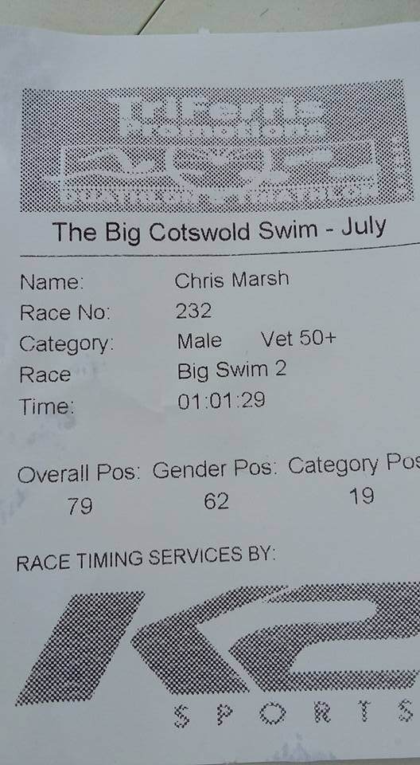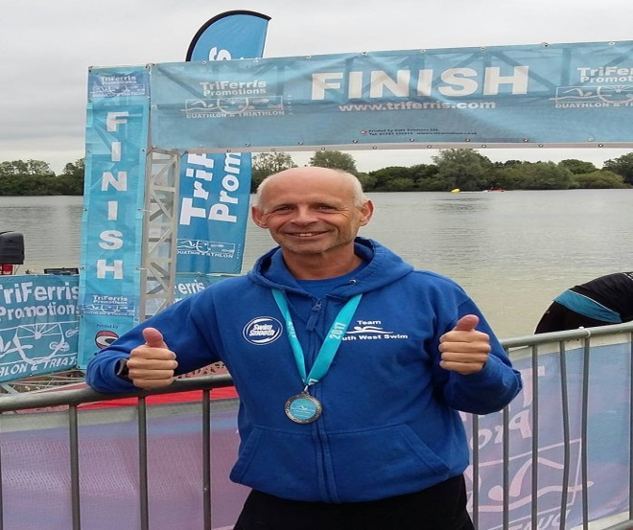

Now I had a taste for a bit more of this open water swimming but wanted to try the sea and the first one that caught my eye was the Padstow to Rock estuary swim for Marie Curie. There was a bit of a story behind this one, when I phone up to book a place they said that all the entries were now full…..unless of course I was an Elite Swimmer. I asked what the criteria was to be an “ Elite Swimmer “ and was told that you had to complete the mile crossing in less than 30 mins . “ Ah yes that’s me“….I’m just glad the lady couldn’t see the embarressed look on my face as I paid over the Elite Swimmer entry money. Now I needed plenty of open water speed training to pull this one off but in theory I should have been fine???? Well we booked up a campsite and set off to Cornwall and on Saturday the 6th of August I wandered into to the race reception and collected my Elite Swimmers pack. As high tide approached we had the swim brief, entered the water and started. Firstly my old friend the leaking google appeared giving me a good dose of sea salt eye bath , then as I struggled to clear the problem I swam and was carried by the tide a long way off course . Half way across the estuary the swell became quite big and the swim got very difficult, then the jelly fish appeared! Dodging through them I again went off course. I was unusually getting tired; the swim was not going well and I struggled, definitely not an Elite Sea Swimmer!! LOL. At last there was the finish jetty, I made it! and what a fantastic crowd and warm reception , a hot coffee, a medal and best of all hot Cornish Pasties donated by Rick Stein to every swimmer ….Brilliant. I want to do this one again I think my time was about 36 mins but I’m sure with practice I could beat that magic 30!
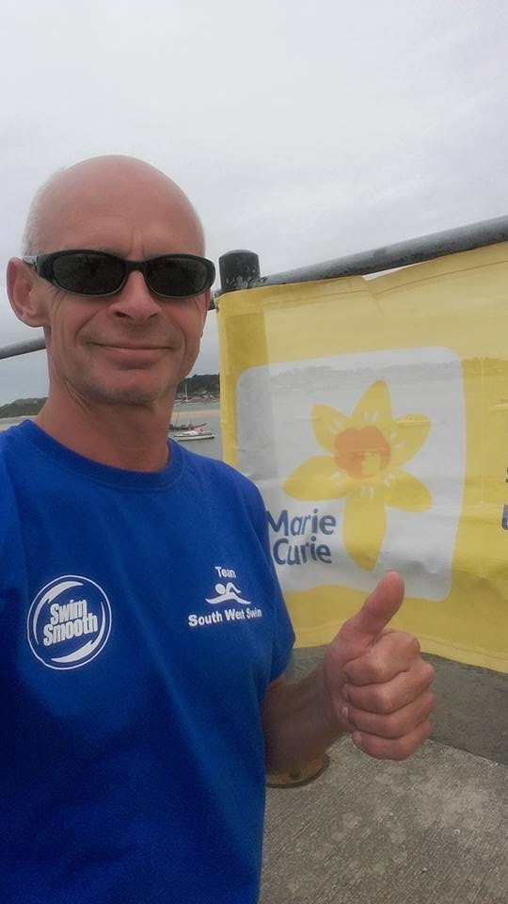

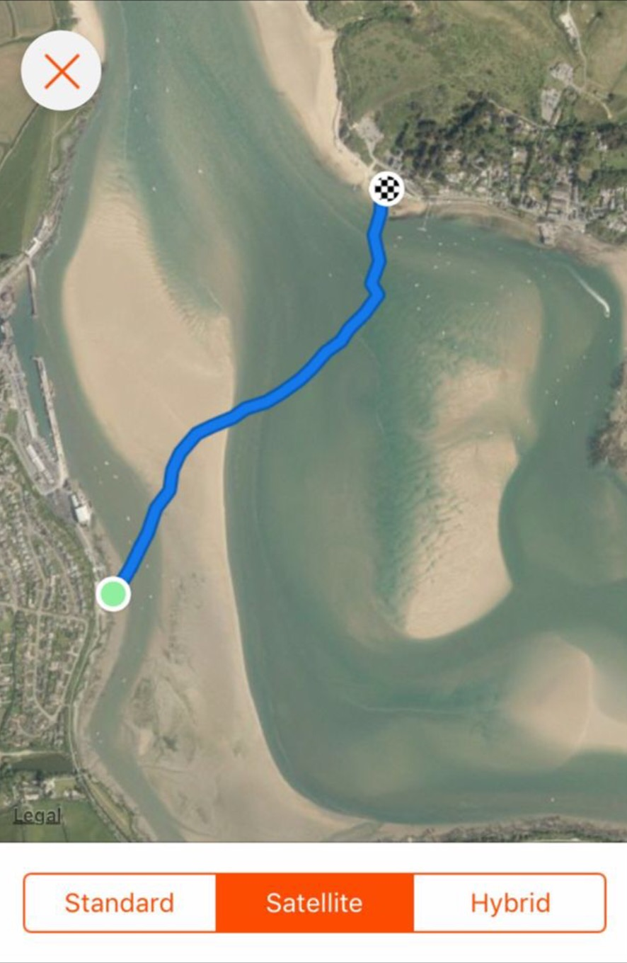

Now the Big One, my Lake Coniston End to End Charity Swim.

This is what it’s all about for me: the challenge was to find a swimming instructor / Club that could take me from breathless, wind milling 2 length and stop swimmer to some one that could feel comfortable in the water at Triathlon events. I never imagined that this would happen! I signed up for this swim because I am mad and wanted to do something that I currently couldn’t do , something that would scare me into some pretty serious training and Coniston was the one . SWS have taken me from a novice swimmer to this monster Coniston swim and I am so grateful for their sponsorship, training and advice this year.

I turned up at Coniston an absolute nervous wreck totally unsure whether I would make this swim to the end or whether there was a safety boat with my name on it! But I knew I had trained all summer for this day and despite some pain from a rib injury (cycle crash) I was going to give it my all. It was so nice to meet up with the gang from SWS at the swim reception area and have a chat, I think that calmed me a bit (Thanks Guys).

5.2 miles to get to the end , and were off !, then something special happened, everything kicked in , the adrenaline was totally pumping and I focused on my stoke and breathing and just took off . I was so enjoying the scenery, the hundreds of other swimmers and the passing ferry boats that the time passed swiftly. I mentally challenged myself to swim just 1 mile at a time, usually to the next feed station boat , then another and another , and that’s how the swim went , with one mile to go I was still on a high and even increased my pace to the finish . This swim was EPIC in every sense of the word, the marshals pulled me out of the water, my legs were like jelly and I felt quite dizzy and maybe dehydrated, but you should have seen the smile on my face ….priceless. I will never forget this day.

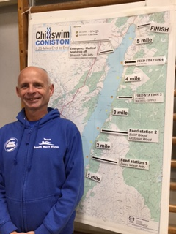

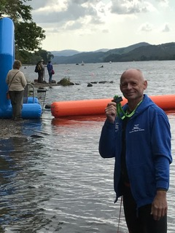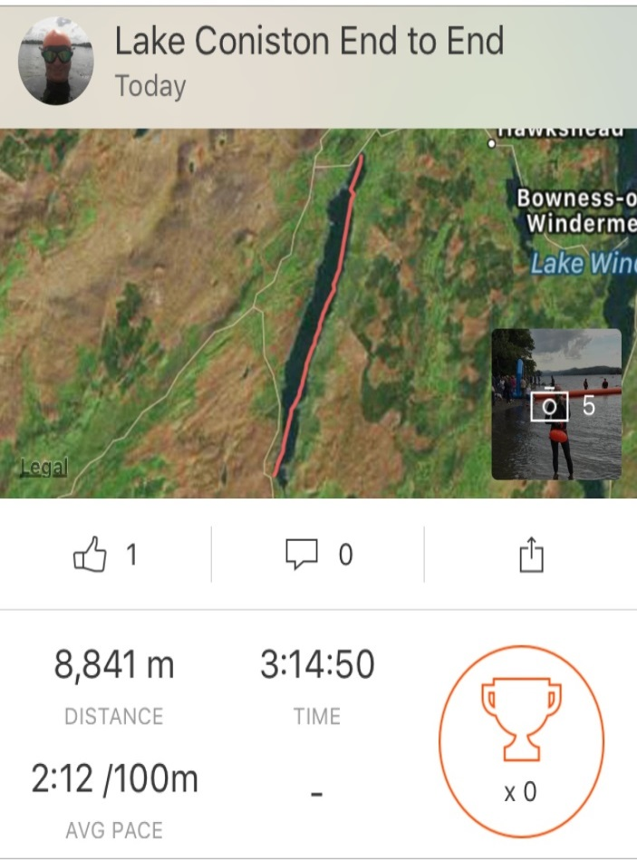

Well that’s enough excitement for one summer, once again thankyou Jason Tait for everything!

Now it’s back to the pool, lots of hard work is now needed to get into shape for next year’s challenges ….IRON MAN TRIATHLON for sure, but what swims to do??? Let’s wait and see.

See you all in the pool

Chris Marsh

